Task 2: Core Security Concepts Explainer
- CIA TRIAD

1. Confidentiality

What is confidentiality?
Confidentiality is basically about keeping information private. It means that only the people who are supposed to see certain information should be able to see it.
For example, my college portal contains things like my marks, attendance, personal details, and other information related to me. I would obviously not want another student to be able to open my account and see all of that.
So, the easiest way I remember confidentiality is, who is allowed to see this information? If the wrong person gets access to it, then confidentiality has been affected.

Real-world scenario
Imagine that I log into my college portal from a computer in the lab. I finish checking my marks and attendance, but I forget to log out before leaving, a few minutes later, another student uses the same computer, since my account is still open, they can see my marks, attendance, and personal information.
They did not change anything nor did they delete anything either, the main problem is that they were able to see information that they were not supposed to see. This is a confidentiality problem.
The same thing could happen with other types of information too. For example, if someone gets access to another person's private messages, bank details, or medical records without permission.

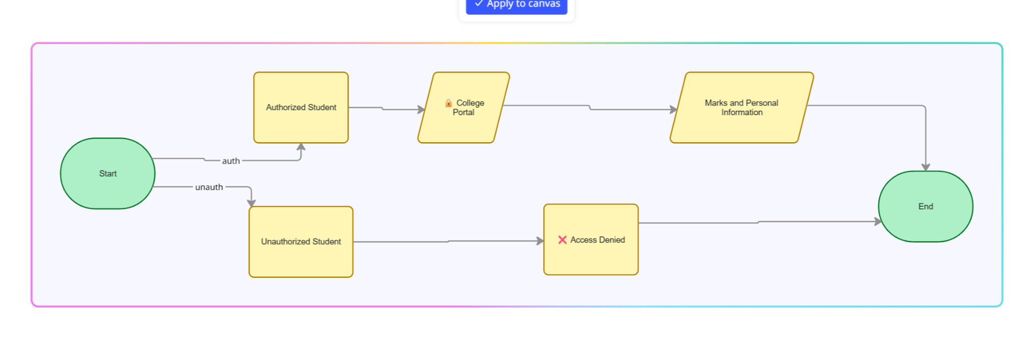

2. Integrity
Integrity means making sure that information stays correct and has not been changed without permission. For example, if my Physics mark is 85, I expect the college portal to show 85. If someone secretly changes it to 45, the information is no longer accurate.
Real-world scenario
Imagine that my Physics teacher enters my mark as 85 into the college database, later, someone somehow gets unauthorized access to the database and changes my mark from 85 to 45. The database is still working. I can still log in and see my marks. The information has not disappeared either.
But there is a problem, the information is now wrong because someone changed it without permission, this means the integrity of the information has been affected.
This does not only apply to marks. Imagine someone changing the amount in a bank transaction etc
Integrity matters because we depend on information being accurate. If we cannot trust the information stored in a system, people could make decisions based on something that is completely wrong.
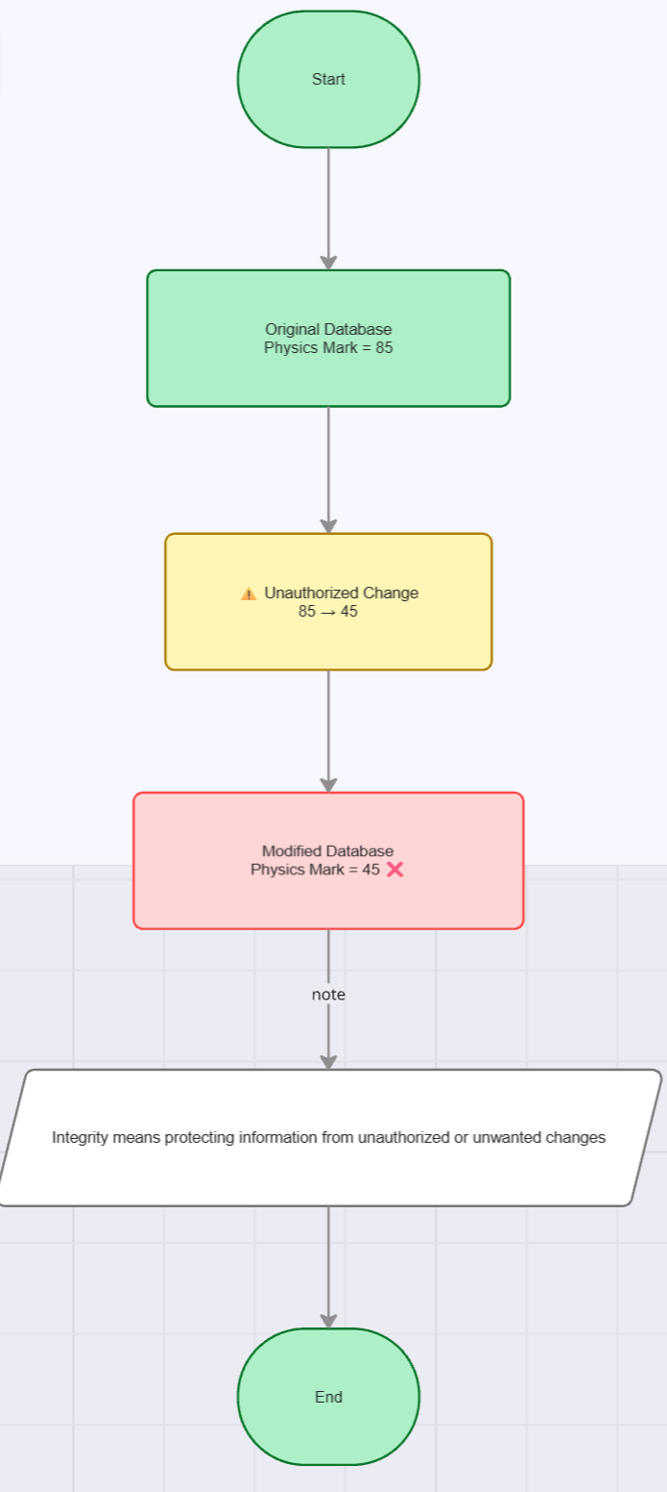

3. Availability
Availability means making sure that a system or information is actually accessible when people who are allowed to use it need it. At first, this sounds really obvious, but it is an important part of cybersecurity, there is no point in having perfectly protected information if nobody can access the system when they need it.

Real-world scenario
Imagine that my college uploads the exam timetable to the student portal and as soon as the timetable is released, hundreds or even thousands of students try to open the website at the same time. The server becomes overloaded and the website stops responding. Instead of seeing my exam dates, I just get an error message and the timetable has not necessarily been deleted. The problem is simply that I cannot access it when I need it.
One example is a DDoS attack, which stands for Distributed Denial-of-Service. In a DDoS attack, a very large number of requests are sent towards a service, which can make it difficult for normal users to access it.
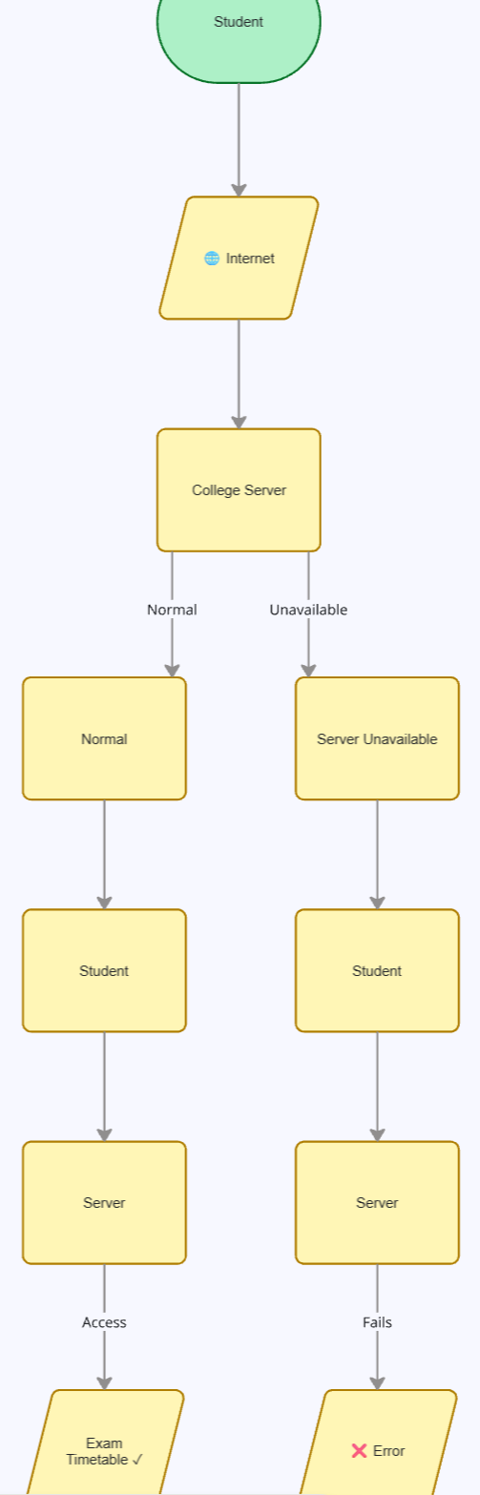

4. Authentication and Authorization
Authentication and authorization are two terms that sound almost the same but to differentiate them
Authentication = Who are you?
Authorization = What are you allowed to do?
Authentication is about checking someone's identity.
Authorization comes after that and decides what that person is allowed to access or do.

Real-world scenario
Imagine that I want to enter a college computer lab.I scan my student ID card and the system checks whether that ID actually belongs to me. This is authentication because the system is trying to verify my identity.
As a student, I might be allowed to use the computers, access study material, and use certain software, however, I probably should not be allowed to change server settings, create administrator accounts, or change another student's permissions. That second part is authorization.
So even if both a student and a lab administrator successfully log into the same system, they can have completely different permissions.

Authentication helps stop people from pretending to be someone else and Authorization makes sure that even after someone has logged in, they cannot automatically access everything in the system. This is why both are needed. Simply knowing who someone is does not mean that they should have access to everything. Multi-factor authentication, is another way of making authentication stronger. Instead of relying only on a password, it can require something extra, such as a verification code or another form of confirmation.
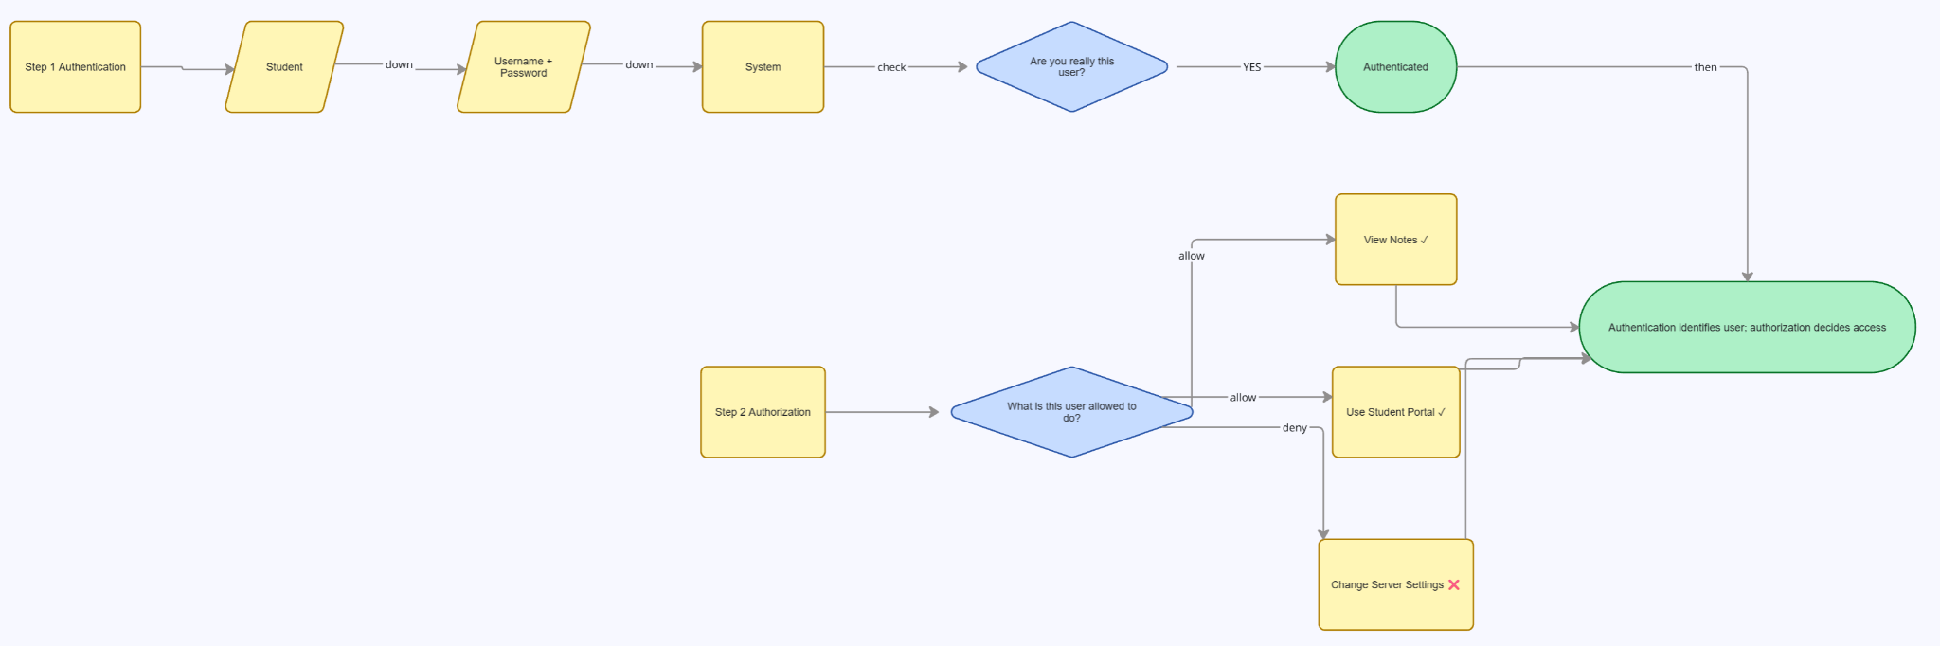

5. Encryption and Hashing
Encryption and hashing both change information into another form, but they are used for different purposes.
Encryption changes readable information into a form that is difficult for someone without the correct key to understand. The original information can later be recovered through decryption.
Hashing takes information and produces a fixed-length value called a hash.
Encryption = protect it so the intended person can read it later.
Hashing = create a digital fingerprint that can be checked later.

Real-world scenario

Imagine that I send a private message to my friend through a secure messaging application. The original message could be:
Meet me at 5 PM
If the message is encrypted, it is changed into protected data before it travels through the network. Someone who somehow gets hold of the encrypted data should not be able to simply read the original message.
The person receiving the message can use the correct key to see:
Meet me at 5 PM
So the basic process is:
Readable Message → Encryption → Protected Data → Decryption → Readable Message
Hashing can be used for a different purpose, imagine that I create an account on a website and choose a password. A properly designed website should not simply keep everyone's actual passwords in an easily readable form. Instead, it can use a hashing function to create a hash from the password.
For example:
My Password → Hash Function → Hash Value
When I log in again, the system can process the password I enter and compare the result with the stored value. The important part is that hashing is designed to be one-way. It is not simply an encrypted password that the website can decrypt whenever it wants.
